**Adapter Design Pattern**

**Assignment - 2**

Name - Heet Dobariya Roll No. - 22BCP177 Group - G5

* **Program :** Implement adapter design pattern for Packaging example.
* **UML Diagram :**

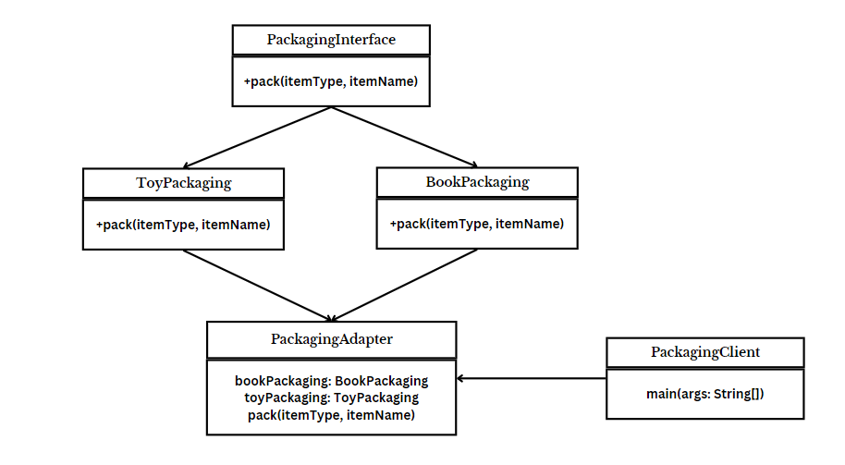ss

* **Code :**

interface PackagingInterface

{

void pack(String itemType, String itemName);

}

class BookPackaging implements PackagingInterface

{

@Override

public void pack(String itemType, String itemName)

{

System.out.println("Packaging " + itemType + ": " + itemName);

}

}

class ToyPackaging implements PackagingInterface

{

@Override

public void pack(String itemType, String itemName)

{

System.out.println("Packaging " + itemType + ": " + itemName);

}

}

class PackagingAdapter implements PackagingInterface

{

BookPackaging bookPackaging;

ToyPackaging toyPackaging;

public PackagingAdapter(String itemType)

{

if (itemType.equalsIgnoreCase("book"))

{

bookPackaging = new BookPackaging();

} else if (itemType.equalsIgnoreCase("toy"))

{

toyPackaging = new ToyPackaging();

}

}

public void pack(String itemType, String itemName)

{

if (itemType.equalsIgnoreCase("book"))

{

bookPackaging.pack(itemType, itemName);

} else if (itemType.equalsIgnoreCase("toy"))

{

toyPackaging.pack(itemType, itemName);

}

}

}

public class PackagingClient

{

public static void main(String[] args)

{

PackagingAdapter packagingInterface = new PackagingAdapter("book");

packagingInterface.pack("book", "The Great Gatsby");

packagingInterface = new PackagingAdapter("toy");

packagingInterface.pack("toy", "LEGO Set");

}

}

* **Output :**

